NATIONAL UNIVERSITY OF SCIENCES AND TECHNLOGY

(DEPARTMENT OF MECHANICAL ENGINEERING)

FUNDAMENTALS OF PROGRAMMING

NAME: SYED ALI NAQI

ID: 466889

SECTION: B

**TASK 1:**

#include <iostream>

using namespace std;

int main (){

int numbers , first =0, second =1, next;

cout<<" enter number of terms you wish to have in your sequence :"<<endl;

cin>>numbers;

cout<<" the sequence is :"<<endl;

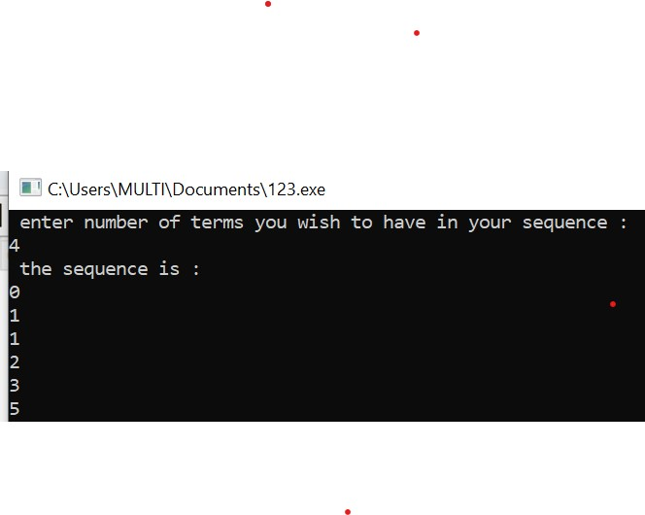 for ( int i =1; i<numbers ; i++){

for (int j=1; j<=i; j++){

cout <<first <<endl;

next =first+second;

first =second;

second= next;

}

cout;

}

return 0;

}

**TASK 2:**

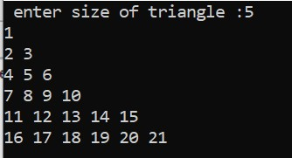#include <iostream>

using namespace std;

int main (){

//

int size, num= 1;

cout <<" enter the size of triangle :";

cin>> size;

for( int h=0; h<=size ; h++){

for( int a=0; a<=h; a++){

cout<<num<<" ";

++num;

}

cout <<endl;

}

return 0;

}